38.48: a) As in Example 38.10, using four-place values for the physical constants, 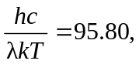 from which
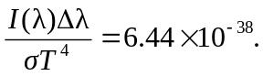
b) With 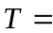2000 K and the same values for 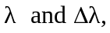
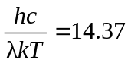
and so
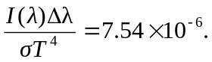
c) With 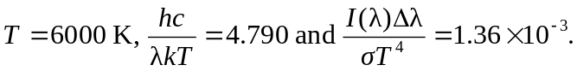
d) For these temperatures, the intensity varies strongly with temperature, although for even higher temperatures the intensity in this wavelength interval would decrease. From the Wien displacement law, the temperature that has the peak of the corresponding distribution in this wavelength interval is 5800 K (see Example 38.10), close to that used in part (c).

